**Ideation Phase**

**Define the Problem Statements**

|  |  |
| --- | --- |
| Date | 2 February 2026 |
| Team ID | LTVIP2026TMIDS65419 |
| Project Name | Flavour Fusion-AI Driven Recipe Blogging |
| Maximum Marks | 2 Marks |

**Customer Problem Statement:**

Create a problem statement to understand your customer's point of view. The Customer Problem Statement template helps you focus on what matters to create experiences people will love.

A well-articulated customer problem statement allows you and your team to find the ideal solution for the challenges your customers face. Throughout the process, you’ll also be able to empathize with your customers, which helps you better understand how they perceive your product or service.

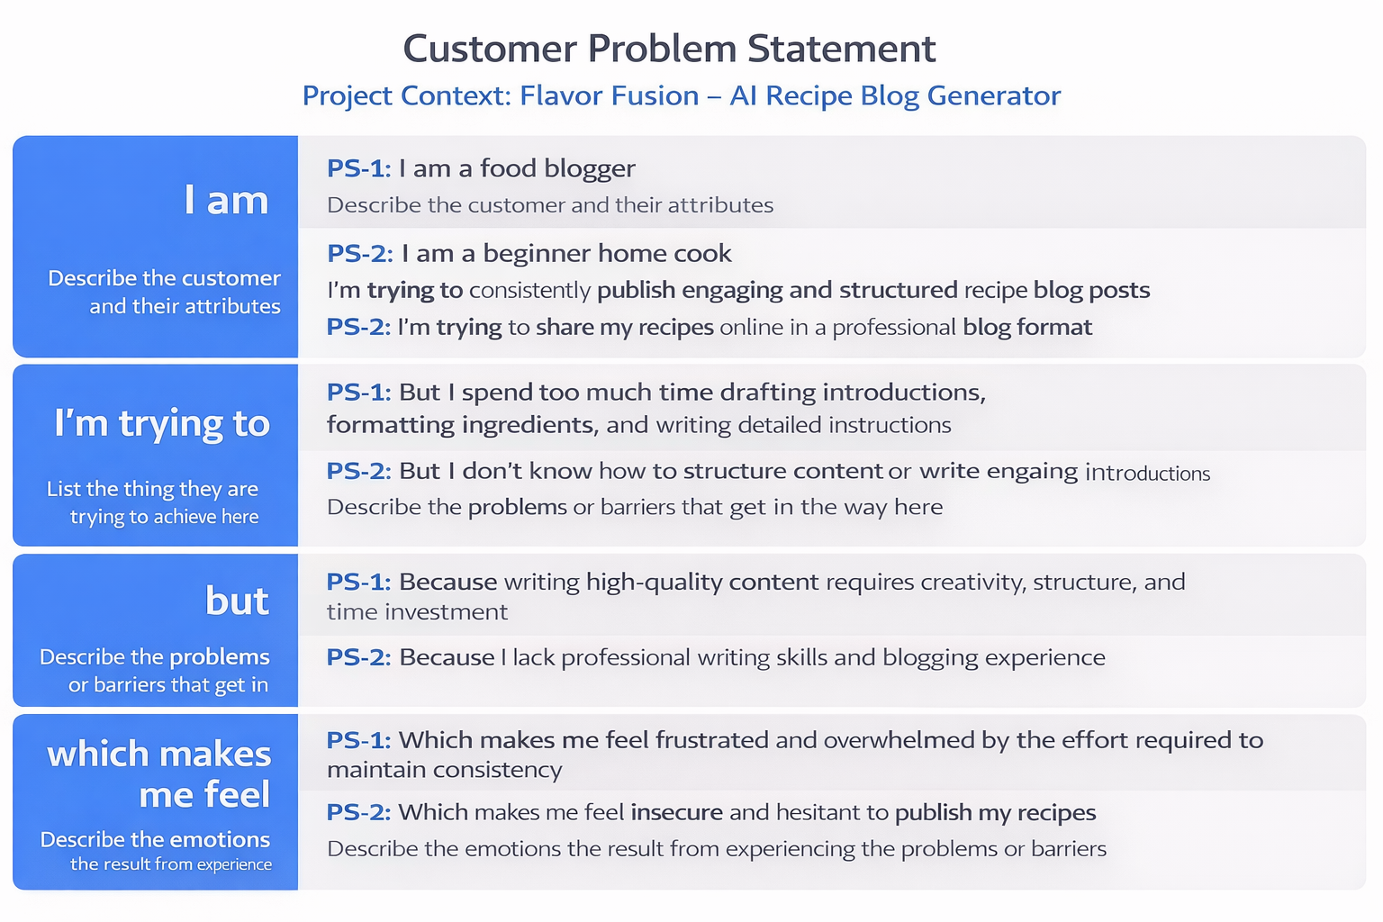

**Example:**

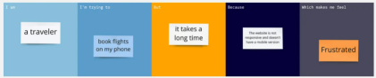

|  |  |  |  |  |  |
| --- | --- | --- | --- | --- | --- |
| **Problem**  **Statement (PS)** | **I am**  **(Customer)** | **I’m trying to** | **But** | **Because** | **Which makes me feel** |
| PS-1 | |  | | --- | |  |  |  |  | | --- | --- | | I am a food  blogger |  | | I’m trying to consistently publish engaging and structured recipe blog posts | But I spend too much time drafting introductions, formatting ingredients, and writing detailed instructions | Because writing high-quality content requires creativity, structure, and time investment | Frustrated and overwhelmed by the effort required to maintain consistency |
| PS-2 | I am a beginner home cook | I’m trying to share my recipes online in a professional blog format | But I don’t know how to structure content or write engaging introductions | Because I lack professional writing skills and blogging experience | Insecure and hesitant to publish my recipes |